Literature Survey

Real-world Anomaly Detection in Surveillance Videos

**Introduction:**

Surveillance cameras are omnipresent in public spaces, aiming to enhance safety, but the capability of law enforcement to monitor footage lags behind. The rarity of anomalous events compared to normal activities underscores the need for automated anomaly detection algorithms. Traditional methods fall short, necessitating intelligent computer vision solutions to sift through vast amounts of footage efficiently. Sparse-coding techniques offer promising avenues, yet environmental changes pose challenges, leading to high false alarm rates. Addressing these challenges, this paper proposes a novel approach leveraging weakly labeled training videos and Multiple Instance Learning (MIL). By treating surveillance videos as bags and segments as instances, the proposed algorithm autonomously learns anomaly rankings. Moreover, the paper introduces a comprehensive dataset of real-world surveillance videos, facilitating benchmarking and advancing anomaly detection research.

Top of Form

**METHODOLOGY:**

1. **Multiple Instance Learning (MIL)**:
   * MIL is utilized as a framework for training the anomaly detection model. In MIL, precise temporal annotations of anomalous events in videos are not required. Instead, only video-level labels indicating the presence of an anomaly in the whole video are needed.
   * Positive bags contain segments from videos with anomalies, while negative bags contain segments from videos without anomalies. The objective is to learn a model that can distinguish between positive and negative bags without relying on precise temporal annotations.
2. **Deep MIL Ranking Model**:
   * Anomaly detection is framed as a regression problem within a ranking framework. The goal is to assign higher anomaly scores to anomalous video segments compared to normal segments.
   * Instead of enforcing ranking on every instance within bags, ranking is enforced only on the instances with the highest anomaly scores in both positive and negative bags. This approach helps push positive instances (anomalies) and negative instances (normal segments) further apart in terms of anomaly score.
   * The proposed model incorporates sparsity and smoothness constraints on the instance scores to encourage sparse anomaly scores (indicating few anomalous segments) and smooth transitions between scores for temporally adjacent segments.

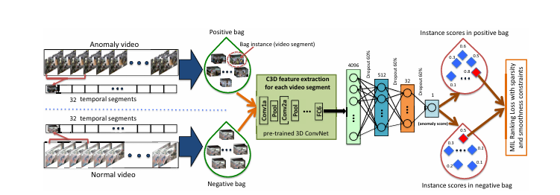

1. **Feature Extraction with C3D Network**:
   * Features for video segments are extracted using the Convolutional 3D (C3D) network. The C3D network captures both appearance and motion dynamics in video action recognition.
   * These features are inputted into a fully connected neural network for further processing and anomaly detection.

SUMMARY OF FINDINGS:

1. **Approach Effectiveness**: The proposed deep learning approach significantly outperforms baseline methods in detecting real-world anomalies present in surveillance videos.
2. **Utilization of Weakly Labeled Data**: By leveraging weakly labeled data and employing a deep Multiple Instance Learning (MIL) framework, the model can learn to detect anomalies without requiring labor-intensive temporal annotations of anomalous segments in training videos.
3. **Dataset Contribution**: The study introduces a new large-scale anomaly dataset containing various real-world anomalies, facilitating the evaluation of anomaly detection methods. This dataset not only serves as a benchmark for assessing the proposed approach but also proves valuable for the task of anomalous activity recognition.
4. **Practical Implications**: The findings suggest practical implications for enhancing surveillance systems' anomaly detection capabilities, which are crucial for ensuring security and safety in various real-world scenarios.

FUTURE SCOPE:

The future scope of this research lies in several key areas. Firstly, there is a need for continued refinement and optimization of deep learning models for anomaly detection in surveillance videos, exploring various architectures, loss functions, and data augmentation techniques. Secondly, efforts should be directed towards expanding and diversifying anomaly datasets to ensure the effectiveness of models across different environments and scenarios. Real-time anomaly detection systems capable of analyzing streaming video feeds and integrating with existing surveillance frameworks should also be developed. Additionally, interdisciplinary collaboration and the exploration of multimodal approaches integrating visual data with other modalities could enhance detection accuracy. Deployment in specific domains, ethical considerations, and privacy implications should be further investigated to ensure the responsible and effective use of surveillance technologies.